**Digitalisation in adult education – examples from Germany**

Volkshochschule im Landkreis Cham e.V., an adult education institution in Germany, is a partner in the Erasmus + project focusing on the exchange of good practices in digitalisation entitled, “MAP - Mapping Digital Methods Applied in Adult Education in Partnership”.

MAP deals with the following questions: What methods, tools and approaches do other European institutions use when advising and training adults? How can digital competencies be assessed transparently and recognized comprehensively? Which applications are best suited for everyday use in adult education? The main focus of MAP is the exchange of the partner institutions and their networking associates on these topics in order to learn from each other and apply innovative educational methods.

After the organisation of the first international partner meeting in Békéscsaba, Hungary in June 2022 and the second meeting in Valladolid, Spain in October 2022, this time VHS Cham hosted the partners in Germany, from 15 to 16 June 2023. During this meeting, the project partners and their colleagues had the opportunity to get insights into digitalisation approaches used in the region of Cham, where VHS Cham is located as a major adult education provider of the region. Some of the good practices presented are explained below:

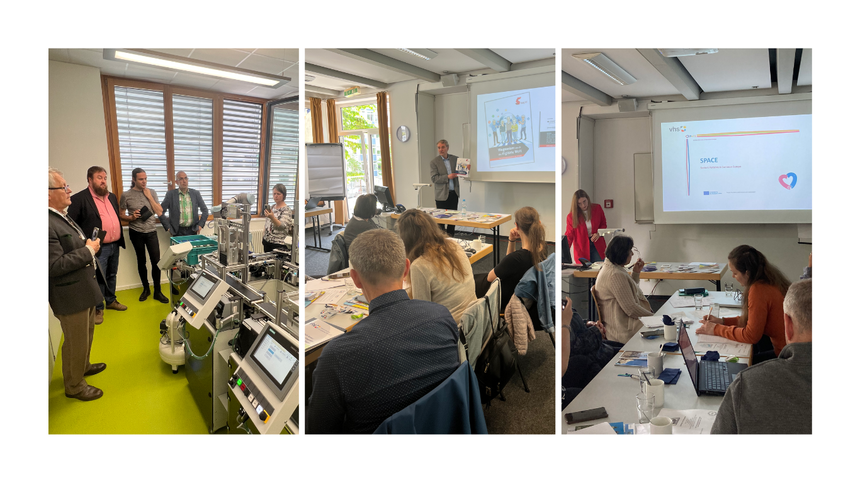

**PC Club for seniors**

VHS Cham offers a special programme for teaching digitalisation aspects to elderly people. The PC club is open for best agers (people between 60 and 75 years old) and the participants themselves have the opportunity to define and come up with topics they want to discuss and learn about. The course was developed based on two aspects: first – often young people are tired of supporting their elderly family members in digitalisation aspects, and second – information days were organised that revealed what seniors really want to learn about, namely using communication tools like WhatsApp, digital calendars, programmes for creating photobooks and getting to know about important documents that need to be filled in online. The PC club is tailored towards the needs of seniors, who meet in small groups on a regular basis.

**Digitalization for young adults in vocational education**

The teachers of the vocational school in Cham presented several aspects of digitalisation in vocational education with young adults. For example, the school offers people looking for employment the opportunity to test digital tools (e.g. stop-motion videos). In addition, the equipment in the school contributes to digitalisation: for example, they have flexible chairs with iPads and desks attached to them, so the students can move freely within the classroom, which encourages action, cooperation and motivation while providing a combination of fun, learning and movements. Teaching is also carried out involving many online tools, like digital smartboards, cooperative working spaces like OneDrive or Microsoft Teams – these approaches offer an increased flexibility and support creating individual learning paths.

**Digitalisation in language learning at VHS**

Using digital tools in language learning is a common practice nowadays and platforms, videos or podcasts are often used in language classes. To guarantee a high effectiveness of these approaches, it is, first, important to build and expand the digital competences of teachers, as those are the ones transmitting digital skills to students. VHS Cham works with several projects that involve digital tools for language teachers: for example, IDEAL is a platform that lists a variety of tools to be useful for digital language teaching. ALL-IN presents a collection of innovative teaching practices that are used in L2 for migrants and with the help of INTERCLab intercultural skills of employers are developed to improve migrants chances on the labour market with the use of the innovative tool ChatGPT.

**Progress of the project**

Lastly, VHS Cham presented some of their international projects that deal with the topic of digitalisation. One of them was for example the project SPACE, which aims at improving digital skills of elderly people by inviting them to share their knowledge on certain traditions and cultural heritage (e.g. they cook something special with an old recipe and produce videos about that). Another presented project was e-EUPA, which provides online materials for people working in an office, also a certification is possible (e.g. for people not having a specific office training done, allows them to prove their competences).

Besides gaining insights into good practices used in the region of Cham, the project partners also discussed project management issues. Among those, one of the most important topics was the Further Training Framework, which involves information and guidelines for training providers, teachers and curriculum developers on digitalisation of adult education. Additionally, during a roundtable discussion, the partners were invited to think about the digital tools that they got to know in Germany and also in the last meetings in Hungary and Spain and whether they can find application potentials of those in their own institutions. This will also be a topic for discussion for the next meeting in Romania, that is planned for September 2023.

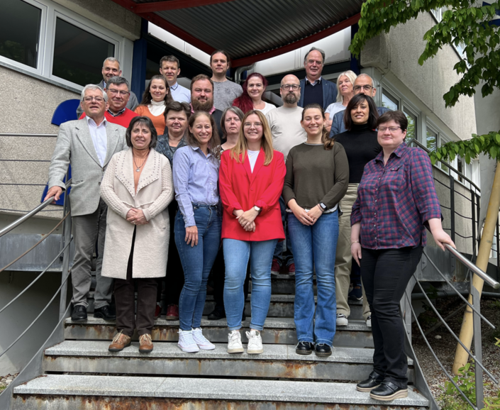

**Partnership:**

|  |  |
| --- | --- |
| Government Office of Békés County | www.kormanyhivatal.hu/hu/bekes |
| Ferenc Gál University Vocational Secondary School and College | [www.gfe-technikum.hu](http://www.gfe-technikum.hu) |
| János Kodolányi University | [www.kodolanyi.hu](http://www.kodolanyi.hu) |
| EFCC Estonian Fieldbus Competency Centre OÜ | [www.efcc.ee](http://www.efcc.ee) |
| Tallinna Polütehnikum | [www.tptlive.ee](http://www.tptlive.ee) |
| Volkshochschule im Landkreis Cham e.V | [www.vhs-cham.de](http://www.vhs-cham.de/) |
| AJOFM Covasna | [www.covasna.anofm.ro](http://www.covasna.anofm.ro) |
| Universidad de Valladolid | [www.uva.es](http://www.uva.es) |